Moreno Institutes in Latvia invites you to:

Playback Theatre
Core Training
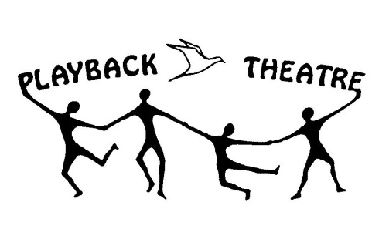
2017, February 11-12 (10:00-18:00) and March 18-19 (10:00-18:00)
Riga

Playback Theatre is an interactive community theatre, where the sharing and spontaneous enactments of personal stories facilitate a community dialogue.
Playback skills involve active listening, collaboration, improvisation, empathy, effective communication and artistic expression. By honouring truth and embodying human experience, it builds personal resiliency, changes communities and impacts the world we live in.

Core training is where it all begins with Playback Theatre. Learn all the basics, with lots of opportunities to practice. Playback forms will be taught — scenes, fluid sculptures, pairs, tableau stories, and more. Each student will have a chance to try the roles of conductor and musician, as well as actor. And, of course, everyone will tell and enact stories together, in the spirit of fun and fellowship. Designed for new and relatively new students.

This course provides a thorough foundation in Playback Theatre. As well as basic skills and performance forms, students will be learning principles, applications & the history of Playback Theatre.

Trainer:
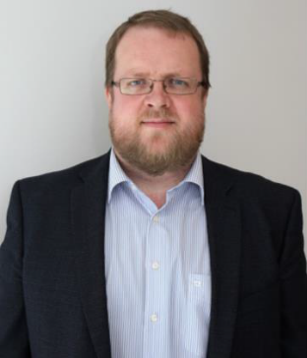
Endel Hango (Teacher, Educator, Practitioner by NBE) has done psychodrama and playback theatre since 2003. He is currently leading Tartu Psychodrama Institute and Tartu Theatre of Spontaneity. He is also applying morenian philosophy and action methods as an adult educator, organisation consultant and coach.

Price: 150 Euros for one weekend
Registration and information: Jolanta Baltina moreno.instituts@gmail.com

